## Advance Web Technology

**React-app**



**Project Supervisor: Sir Safiullah**

**Submitted By:**

Maryam Shehzadi 20006105016

BS-IT BATCH 6

## Session

## (2020-2024)

## University of Management and Technology

## Sialkot, Pakistan

**Question: 01**

Executing the **create-react-app** tool, one can create a new React application called **my-app** by executing the command **npx create-react-app my-app.**

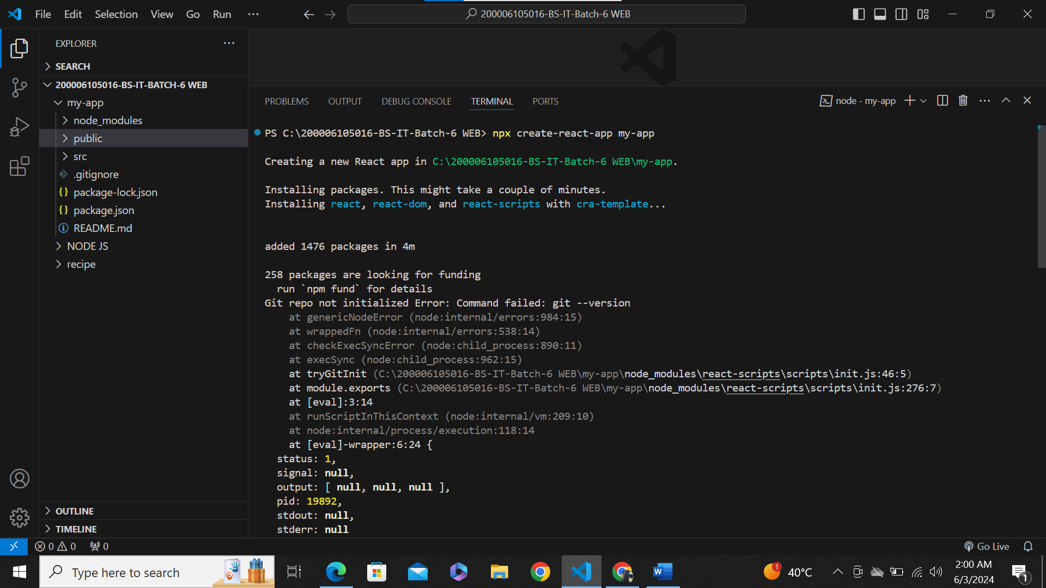

Run the command

Folder name

**Next up is to run this command:**

* **Cd my-app**
* **Npm start**

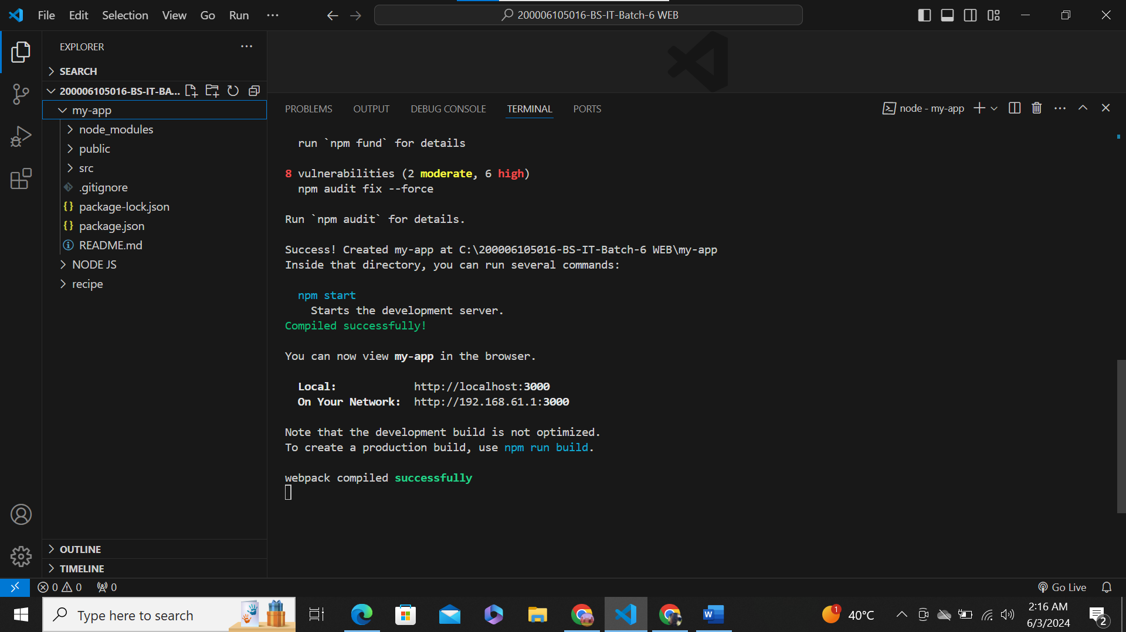

**OUTPUT:**

